**CSE 543: Info Assurance and Security**

**Project Weekly report**

Group-4

Increasing security of the Health-associated data in the Cloud using Machine Learning and Blockchain Technology

Prepared by: Kuntal Ketankumar Nayak (12 PM 2nd Feb, 2021)

Approved by: Sahith Reddy Gaddam (3 PM 2nd Feb, 2021)

Submitted by: Sahith Reddy Gaddam

List of Members:

* Kuntal Ketankumar Nayak (Leader)
* Sahith Reddy Gaddam (Deputy Leader)
* Jaya Teja Mannam
* Jianlun Li
* Siyu Liu
* Suhas Khandiga Suresh
* Xiao Liu

Task Summary:

|  |  |  |  |
| --- | --- | --- | --- |
| Task No. | Task | Member | Task status |
| 1. | Personal health data sharing system   * Modular design (User, Key keeper, Customer) * Data storage in cloud and conceptual model of transactions in Blockchain | Siyu | On going |
| 2. | Database integrity and secure storage in cloud environment   * Cryptographic methods | Jaya | On going |
| 3. | Classifying quality user data   * DBSCAN (data clustering) and RNN * Integration to obtain a quality score using both static and dynamic data | Xiao | On going |
| 4. | ML algorithms to classify data and validate data collected from the personal devices | Jianlun | On going |
| 5. | Secure access control mechanism in untrusted cloud   * Authorization of users without an intermediate third party | Sahith | On going |
| 6. | Secure auditing using Blockchain   * Proof of work | Suhas | On going |
| 7. | Identity management   * Decentralized digital Identity using Blockchain | Kuntal | On going |
| 8. | Use cases in medical Healthcare   * Patient centered model: Patient, Provider shared BC (User authorized) | Kuntal | On going |

Gantt Chart:

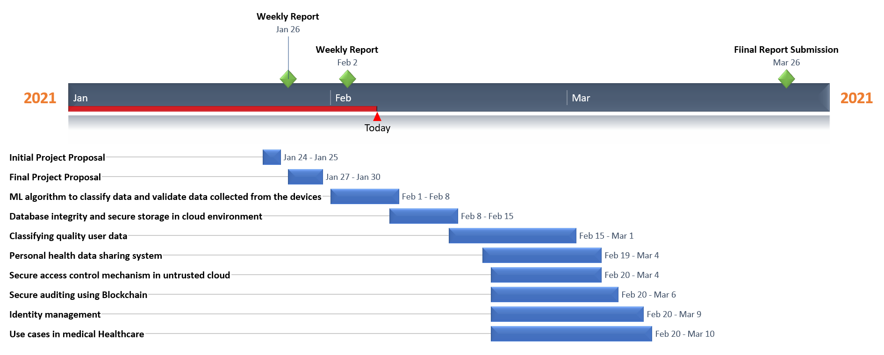

Issues:

* A member “Priya Ganguly” had dropped out from the course last week. Have informed the professor and TA about the same via email and had a zoom meeting to discuss.